Kingsley Oti Amponsah
CS 499 Final Project Submission
2/22/2026
Table of Content
- Self Assessment
- Software Design and Engineering
- Data Structure and Algorythm
- Grazioso Salvare Animal Shelter Project
- Code Review (Video)

Self-Assessment
My name is Kingsley Oti Amponsah, and I am a final year student of Southern New Hampshire University (SNHU), currently pursuing a Bachelor of Science degree in the field of Computer Science with Software Engineering as my main concentration. I am now involved in comprehensive studies that span software design, engineering principles, data structures, databases, and the complexities of algorithms. My academic career is unfolding inside the dynamic arena of computer science, where I am engaged in these studies.
I started this program in July 2023 with less knowledge in the field of computer science. I was recruited in 2022 by IBM field service division and was trained on computer hardware components, basic networking, datacenter management, network cabling, server handling and desktop support. As a beginner, the need to equip myself with theoretical knowledge was a must and I applied to SNHU.
The portfolio that I have meticulously constructed has a multifunctional purpose. It functions as a digital canvas onto which I artistically present the mosaic of abilities and qualities that I have acquired during my time spent working hard at Southern New Hampshire University. This digital repository is more than just a collection of accomplishments; it is a visual tool that has been painstakingly constructed to transcend the borders of academics. It provides a vivid display of my talents and the intrinsic value that I bring to potential employers in the professional realm.

When one delves further into the heart of this portfolio, one discovers that each and every piece of information contained within it symbolizes a beginning point. Not only does it reflect my existing capabilities, but it also encapsulates the path of my skill growth. This collection of artifacts provides a witness to my growth and expertise in these essential domains as I travel through important areas such as software design, engineering processes, data structures, databases, and algorithms. As I go through these key areas, I am able to demonstrate their significance.

Among the wide variety of artifacts that have been compiled for my electronic portfolio, there are certain picks that highlight my enhanced expertise in particular areas. These selections offer a nuanced examination of my talents. At the same time, however, they serve as instances that demonstrate my adaptability and demonstrate my skill in a variety of important areas of knowledge. Each artifact, which was selected with great care, has been improved and presented in accordance with the stringent course requirements that have been established by SNHU. This has been done to ensure that it not only satisfies the academic standards, but also serves as a comprehensive representation of my readiness for potential employment opportunities.

Software Design and Engineering
Artifact: Body Fitness App
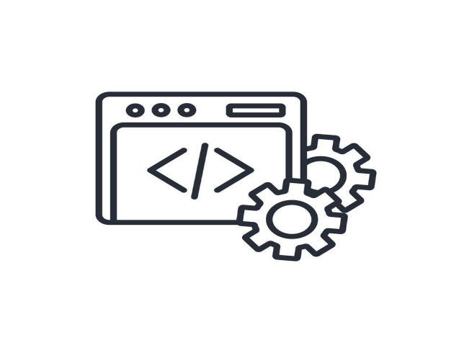
Project Brief
Behavioral changes can be facilitated by self-monitoring of nutrition, activity, and weight through the use of weight loss apps, which are meant to assist users in weight loss. In many cases, they result in better weight control than traditional techniques because they give tools for measuring calories, establishing goals, and gaining nutritional insights. This body fitness application was designed to help users to set weight goals, monitor their progress in weight reduction and receive message alerts that keep them in their quest to fulfil a healthy life.
App goals and requirements
It was with the intention of assisting users in monitoring their daily weight and tracking their progress toward their weight goals that the Weight Tracking app was developed. By offering a straightforward and uncomplicated method of monitoring weight fluctuations over time, it is intended to be of assistance to users in the process of preserving healthy weight. Users can establish weight targets, track their progress, and receive reminders to help them stay inspired along their weight loss journey.
Further information are available in the document Enhancement on Software Development Project and the code files are in the zipped folder Body Fitness App.

Data Structures and Algorithms
Artifact: Image Augmentation

Justification and purpose
This artifact is a key factor in showcasing my skill and knowledge in the area of image augmentation. It also demonstrates my abilities on how to use CNN model on CIFAR-10 datasets to improve the resolution of an image without the traditional way of rotating, zooming etc.
Brief on CNN model on CIFAR-10
With the use of picture augmentation, a straightforward CNN will be able to achieve an accuracy of 90.3% on CIFAR-10. Within the realm of machine learning and computer vision, the CIFAR-10 dataset is a collection of photographs that are frequently utilized for the purpose of training algorithms. According to studies on machine learning, it is one of the datasets that is utilized the most frequently. For starters, 60,000 32x32 color pictures are included in the CIFAR-10 dataset, which is organized into ten distinct categories. Airplanes, automobiles, birds, cats, deer, dogs, frogs, horses, and trucks are the ten distinct classes that correspond to the many types of vehicles. Every category has a total of 6,000 pictures.
Further information on the approach, code snippets and results of the project are shown in the Enhancement on Data Structure & Algorythm code documents and the Image Augmentation Code files.
Database
Artifact: Grazioso Salvare Animal Shelter Project


Brief
To ease the classification of canines that are eligible for search-and-rescue training, the Grazioso Salvare Dashboard project intends to provide a web interface that is comfortable for users to navigate. To gain access to pertinent data, Grazioso Salvare, an international corporation that specializes in the training of rescue animals, works in conjunction with a non-profit organization that operates an animal shelter in the Austin, Texas area. The dashboard gives users the ability to select dogs according to the sorts of rescues they are interested in, read information that is specific to the dogs, and display breed distributions and geographic regions.
The approach of the project; tools and techniques used; as well as procedures and steps are detailed in the Enhancement on Database Project and the zipped folder GraziosoSalvareProject.

